Project 3: Group 6

Rick Trevino

Ian Kriner

Mohak Kant

Ifeanyi Anyaeto

**Noisy 1:**

We choose to use a stopband filter to target only the sinusoids of the noise which was located between 960 Hz and 1200 Hz. This method was chosen since the noise consisted of very specific, and continuous frequencies. Applying the stopband filter removed the continuous noise signal and left us with a relatively low noise frequency.

* We found the frequencies that needed to be stopped by the stop band filter using the signalAnalyzer tool and the power spectrum. Through this, we found that a stop band with normalized cutoff frequencies of .12 O to .14 O was needed to filter the noise. To shrink the order down to 12 we used a pass of up to .09 O and everything above .15 O, this allowed for an ample transition period to reduce the order needed to make an effective filter. Also, the filter order was found by experimentally by a combination of adjusting the order and the Stopband Weight.
* The Impulse and the Frequency Response of the Bandstop filter are shown below.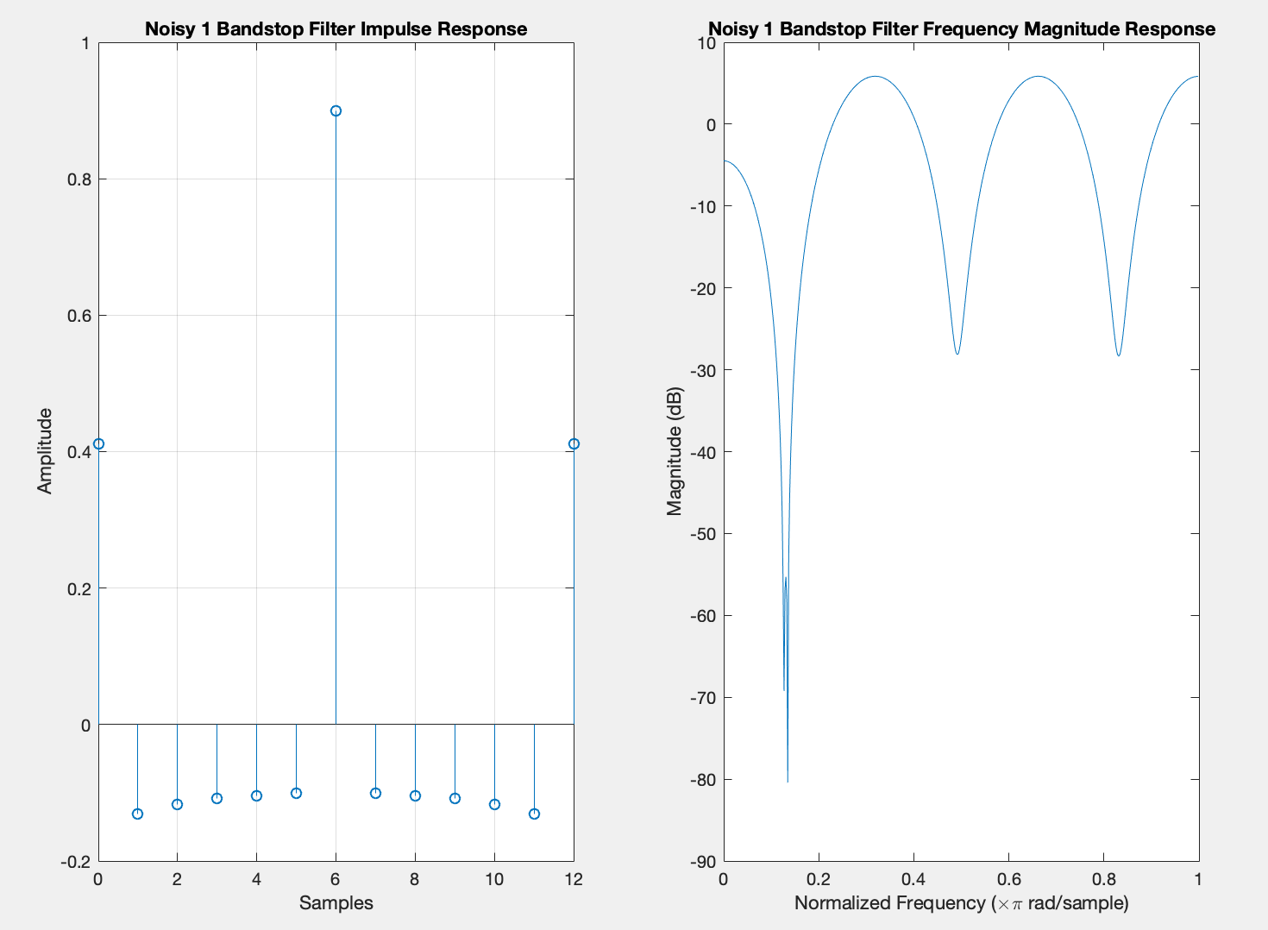
* This is the Signal, Power Spectrum of the Original Signal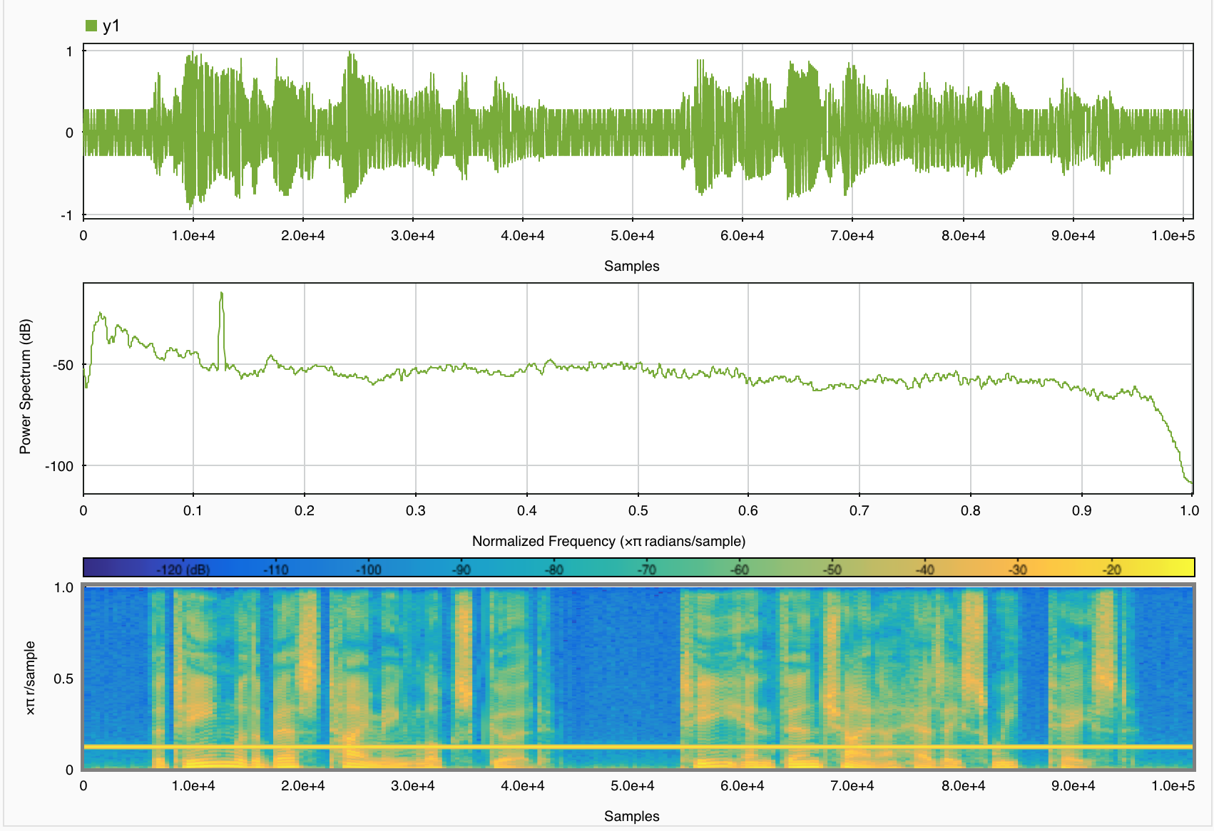
* This is the Signal, Power Spectrum of the Filtered Signal. Clearly, from the spectrogram that dark solid yellow line is removed. Also, the noise in the signal is removed.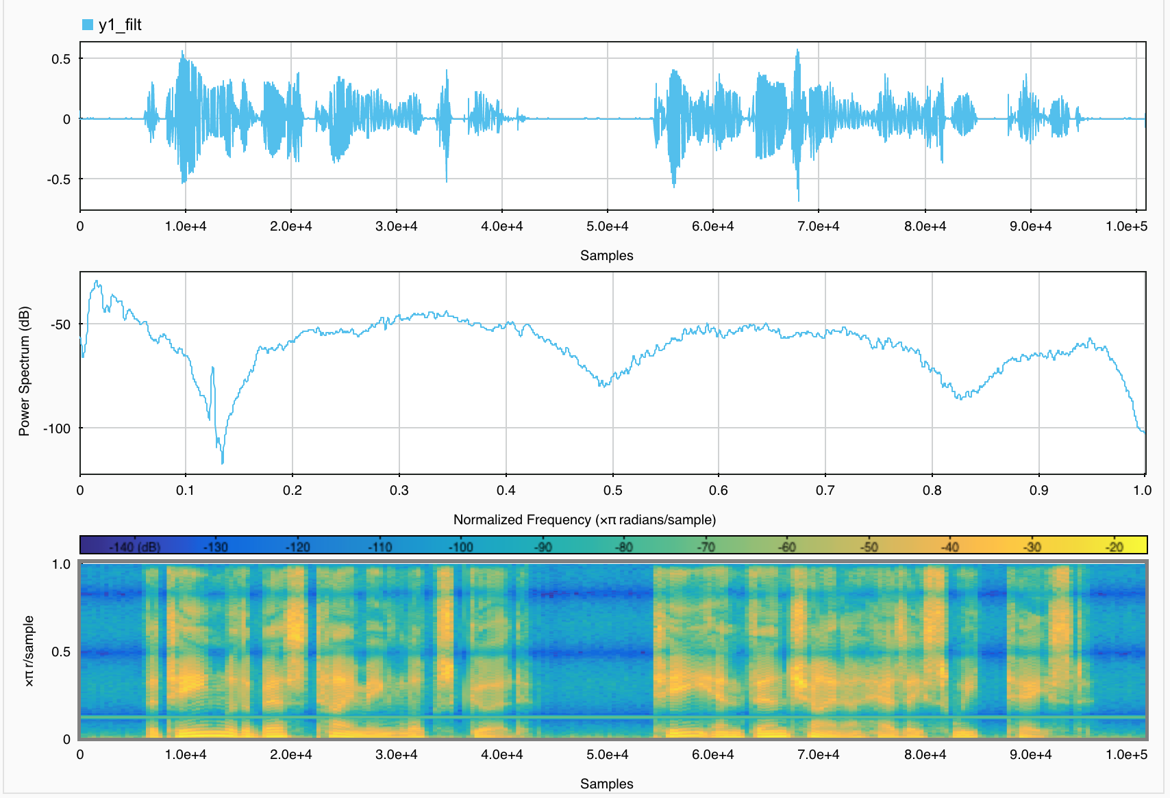

**Noisy 2:**

For this sound wave, we decided to use to use the low-pass filter in conjunction with a Gaussian window filter.

From the signalAnalyzer spectrogram, we reverse engineered that the instead of totally blocking out higher frequencies, the filtered sounded better if we provided kind of a smoothing to the higher frequencies. So, basically like a larger transition band. Also, blurring of a signal is basically removing higher frequency components and the humming noise in the audio is an example of white noise. So, the guess was to remove it smoothly using a Gaussian filter and it worked it to be better in conjucture with a Lowpass filter. The Gaussian filter used was of order 12, cutoff Frequency 0.1 O, mean = 0 and Standard Deviation = 2.5.

The impulse and frequency response of the filter are shown below.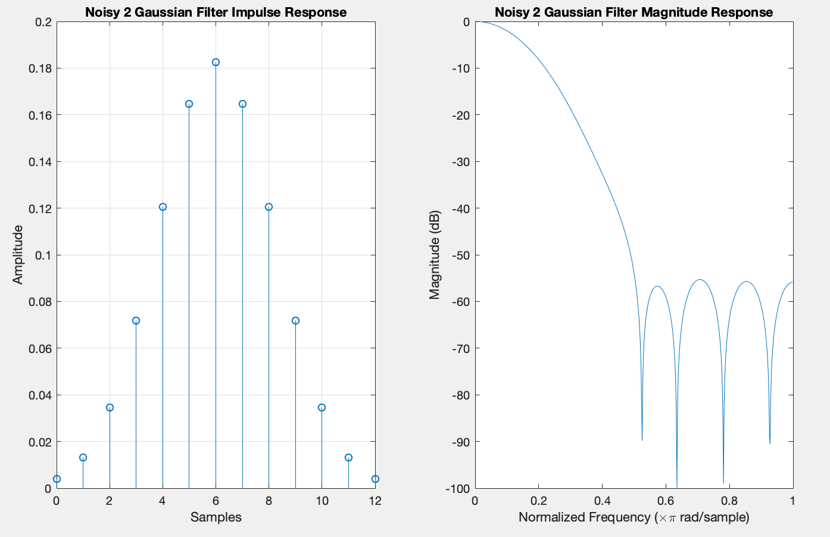

After this, the noise consisted of mostly frequencies higher than the speech, we used the low pass filter of order 68 to get rid of all of the noise frequencies above the speech. We choose a filter with a stop at .1 and a pass at .075 to allow for an ample transition period to minimize the order of the filter. We also analyzed that an order too low or too high either reduced the amplitude of the signal too much or amplified the noise. We obtained best combinations to be of 52<Order<70 with Passband weight 10. This was done mostly expiremently.

We found the spectrum at which we needed to pass the signal by using the signalAnalyzer tool and looking at the power spectrum to help identify them. Once the frequencies were identified we used the filter designer to build a low pass filter with the stop and pass variables stated above. After convolving the signal with the designed filter, a cleaner signal with minimal noise.

The impulse and frequency response of the lowpass filter is as shown below.

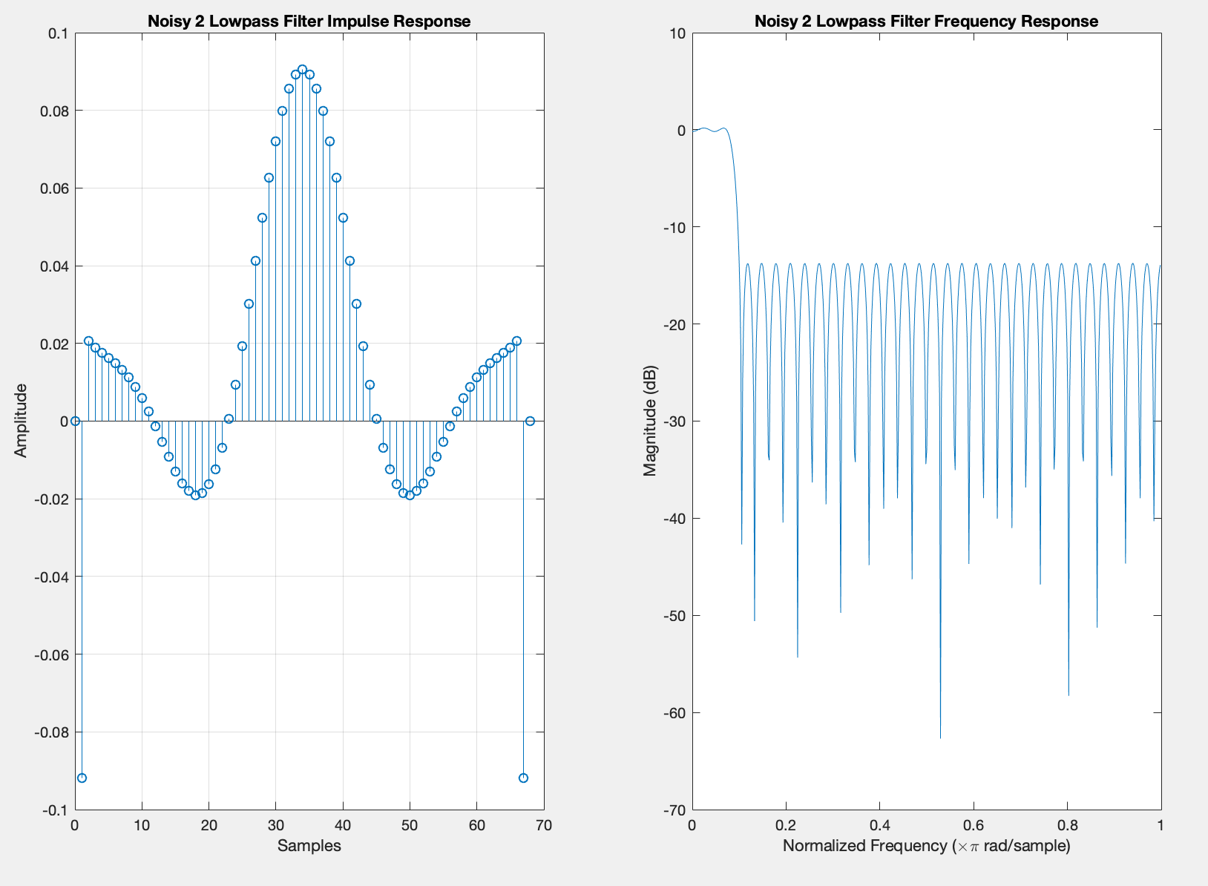

* This is the Signal, Power Spectrum of the Original Signal

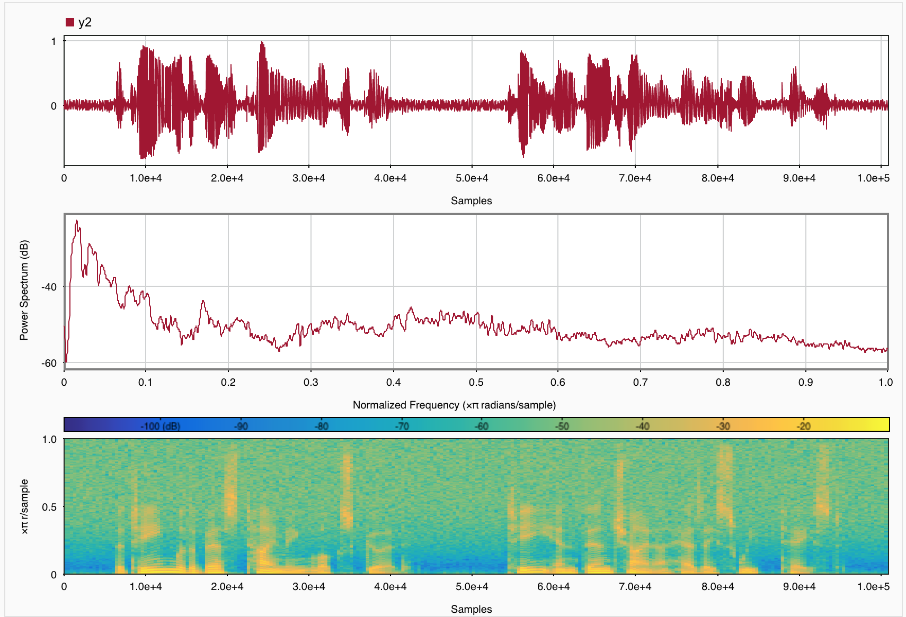

* This is the Signal, Power Spectrum of the Filtered Signal. Clearly, from the spectrogram higher frequencies have been removed with a smooth blurry transition from lower to higher frequencies. Also, the noise from the signal diagram seems removed.

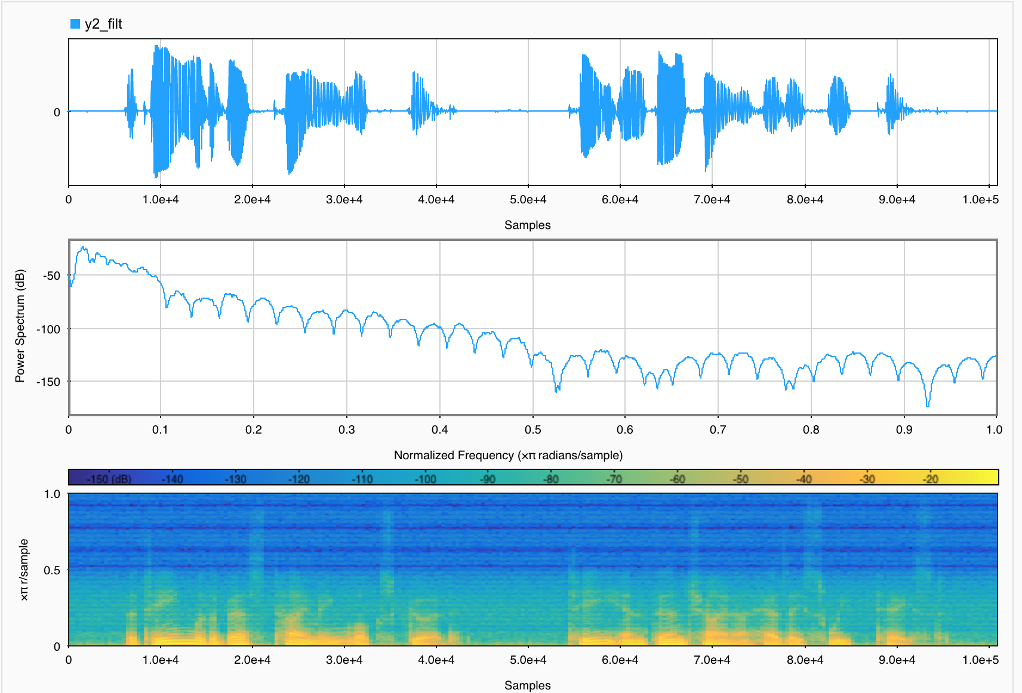

**Noisy 3:**

On the third question, we decided to use a low pass filter of order 26. After looking at the signalAnalyzer, we found that the noise was distributed through the entire signal, but the majority of the speech was located at low frequencies.

* Initially, we chose filter variables for this signal with a pass of .00, a stop of .15. These variables were decided on after experimenting around those ranges to find a combination that worked best for the noise in this signal. After convolving the signal with this filter there was still some noise left over but it was greatly reduced. The speech volume was also decreased to a great degree.

The impulse and frequency response of this filter are shown below.

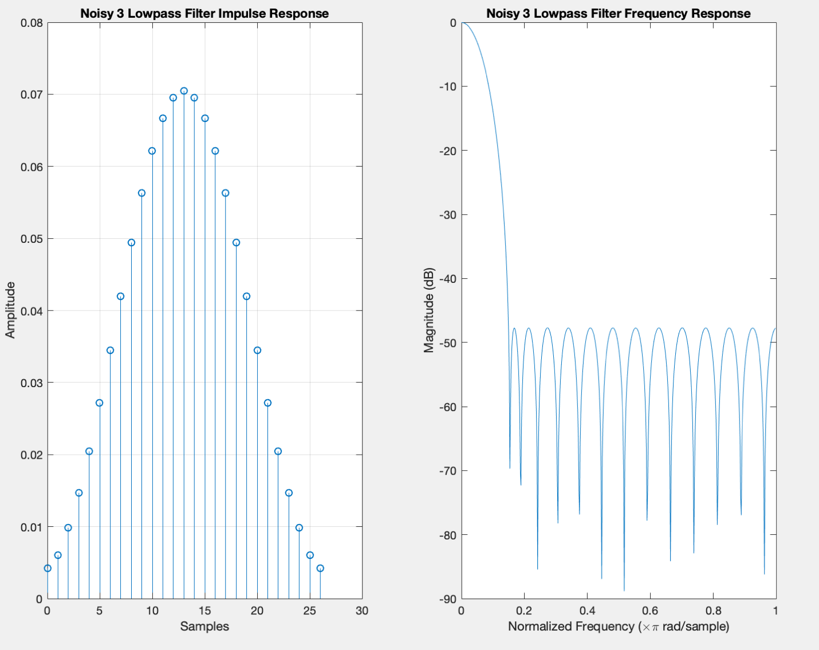

* Secondly, we chose a low pass frequency with a normalized cutoff frequency of. This produced a louder speech signal, but let more noise leak through. It may be hard to see the difference between using the cutoff of .15 and .3, but you will notice the difference in the amplitude.
* We can avoid reducing the speech if we allow more noise through, and we can reduce the amount of noise further by reducing the speech volume, so we had to make a compromise and choose values that gave us a good balance of both. We could also filter as much noise from the signal as possible, and multiply the amplitude of the filtered signal to compensate. The point of all of this is that you must compromise between getting rid of a lot of noise while losing a lot of important speech, or getting rid of less noise while keeping more of the important speech. So, we used the first lowpass filter (the one with the responses shown) and then amplified the signal by a factor of 2.
* This is the Signal, Power Spectrum of the original signal.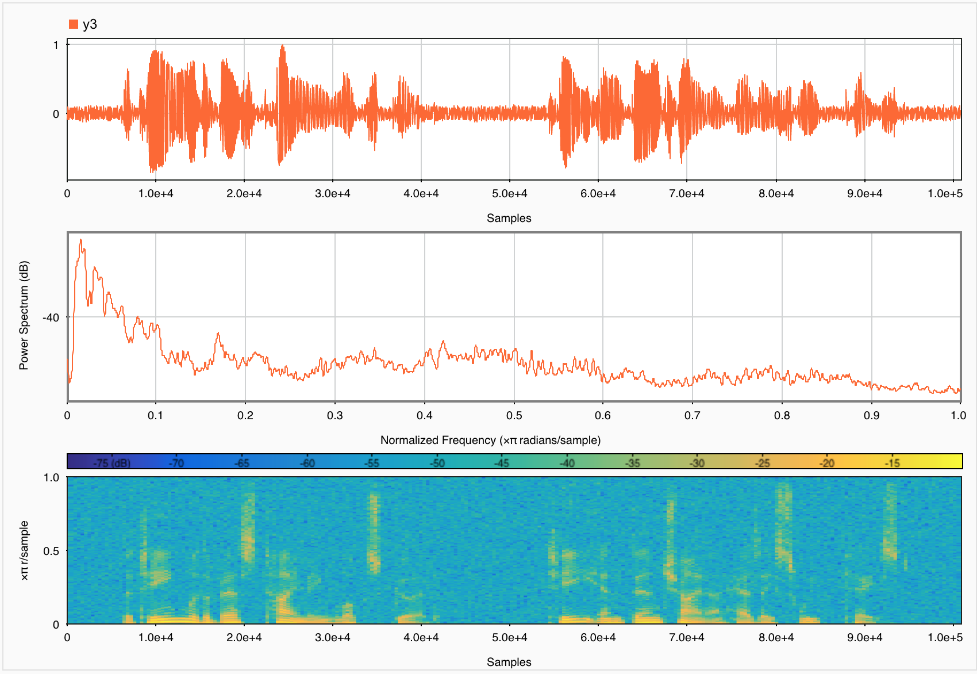
* This is the Signal, Power Spectrum of the Filtered Signal. Clearly, from the spectrogram higher frequencies have been removed. Also, the noise from the signal diagram seems removed.

